SOLVE distribution 2021
﻿
- a) Define with example (i) Population and Sample, (ii) Parameter and Statistic.
Answer:
- A population is the entire group that you want to draw conclusions about.
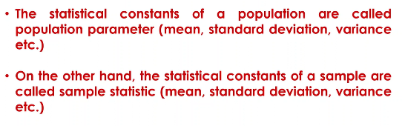
A sample is the specific group that you will collect data from. The size of the sample is always less than the total size of the population.

b) Define Chi-square sampling distribution. Mention some important properties and uses of Chi- square distribution.
A chi-square (Χ2) distribution is a continuous probability distribution that is used in many hypothesis tests.
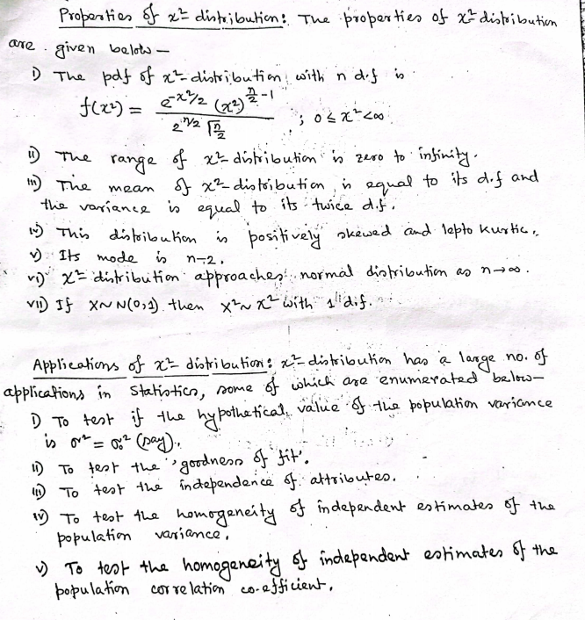
c) Find MGF and CGF of Chi-square distribution. Hence find mean variance, ẞ1, and ẞ2.
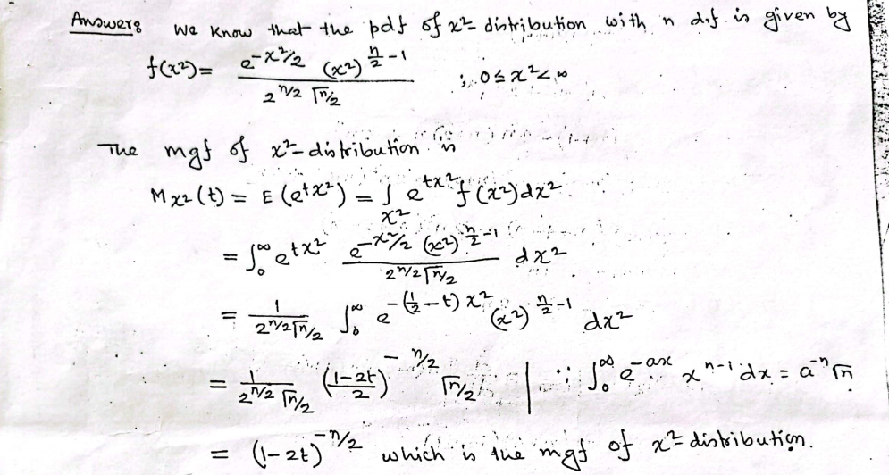
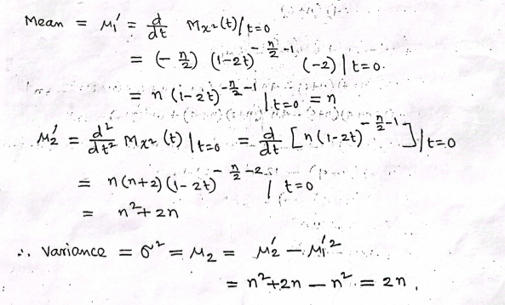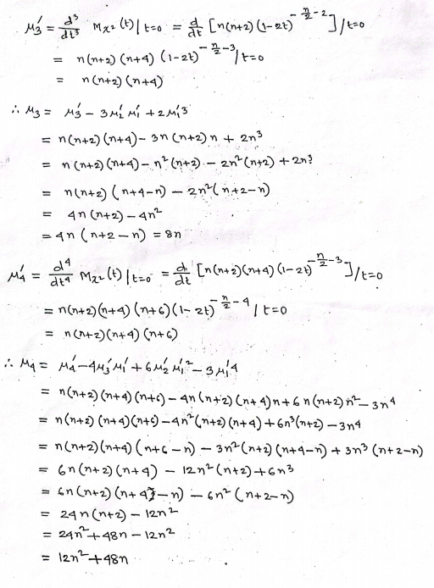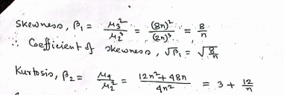
﻿

2020
﻿

1.a) What do you mean by simple random sampling? Illustrate with an example.
Answer: A simple random sample is a randomly selected subset of a population. In this sampling method, each member of the population has an exactly equal chance of being selected.
An example of a simple random sample would be the names of 25 employees being chosen out of a hat from a company of 250 employees. In this case, the population is all 250 employees, and the sample is random because each employee has an equal chance of being chosen. Random sampling is used in science to conduct randomized control tests or for blinded experiments.
b) Suppose we select a random sample of size n from a population and have independent random variables X1, X2,..., X. Do those random variables have the same distribution? Explain.
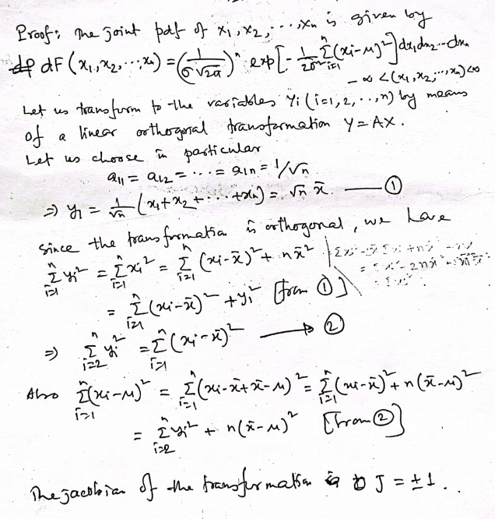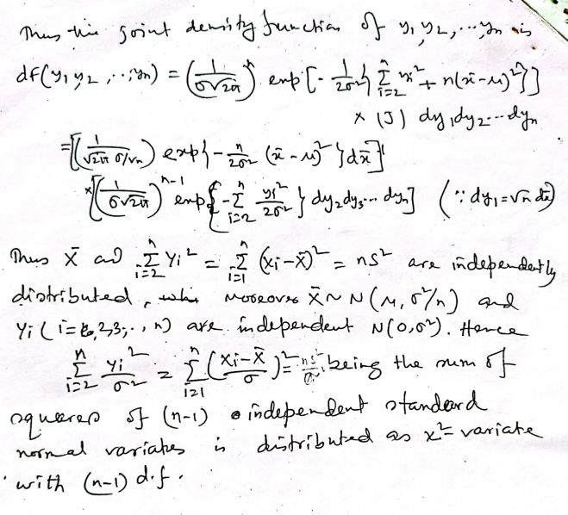
c) Suppose that of six students, the first student has $1, the second student has $2, the third student has $3, the fourth student has $4, the fifth student has $5, and the sixth student has $6. $Consider the 1, 2,3, 4, 5, 6 dollars as the population.$ A sample of two students is selected. What is the probability that the sample mean is equal to $3.5? Write down every step of your calculation.
Answer:
$$N_{C_{R}}={6_{C}}_{2}=15$$
Where N=6 is the number of items in the population and n=2 is the number of items in the sample.
Sample mean for all sample of 2 student :
sample | student | amount | SUM | mean
1 | 1st,2nd | 1,2 | 3 | 1.5
2 | 1st,3rd | 1,3 | 4 | 2.0
3 | 1st,4th | 1,4 | 5 | 2.5
4 | 1st,5th | 1,5 | 6 | 3.0
5 | 1st,6th | 1,6 | 7 | 3.5
6 | 2nd, 3rd | 2,3 | 5 | 2.5
7 | 2nd,4th | 2,4 | 6 | 3.0
8 | 2nd,5th | 2,5 | 7 | 3.5
9 | 2nd,6th | 2,6 | 8 | 4.0
10 | 3rd,4th | 3,4 | 7 | 3.5
11 | 3rd,5th | 3,5 | 8 | 4.0
12 | 3rd.6th | 3,6 | 9 | 4.5
13 | 4th,5th | 4,5 | 9 | 4.5
14 | 4th,6th | 4,6 | 10 | 5.0
15 | 5th,6th | 5,6 | 11 | 5.5
Sampling distribution of the sample mean for n=2
The sample distribution of the sample mean
$μ_{x'}$=$\frac{1.5+2.0+2.5+3.0+3.5+2.5+3.0+3.5+4.0+3.5+4.0+4.5+4.5+5.0+5.5}{15}$
=3.5
So the probability that the sample mean is equal to 3.5 is 1.0 or 100%.

2019

- A) what do you mean by sampling distribution? write down the probability density function of chi-square distribution with n degree of freedom (d.f).
Answer:
A chi-square (Χ2) distribution is a continuous probability distribution that is used in many hypothesis tests.
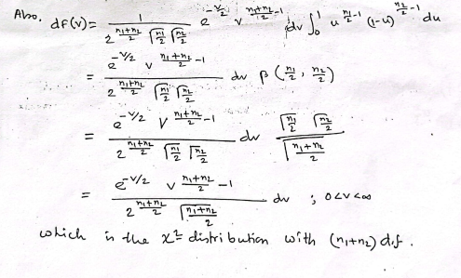

B) if X has a chi-square distribution nd.f find MGF of chi square distribution .
Slv: 2021(1)(c)
C)write down important uses of chi-square distribution.
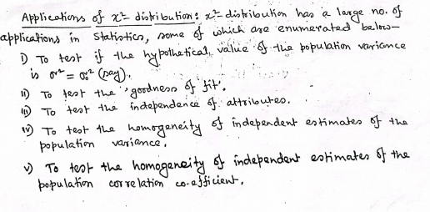same as 2021_1_b_part-2

